Secure Trust Bank 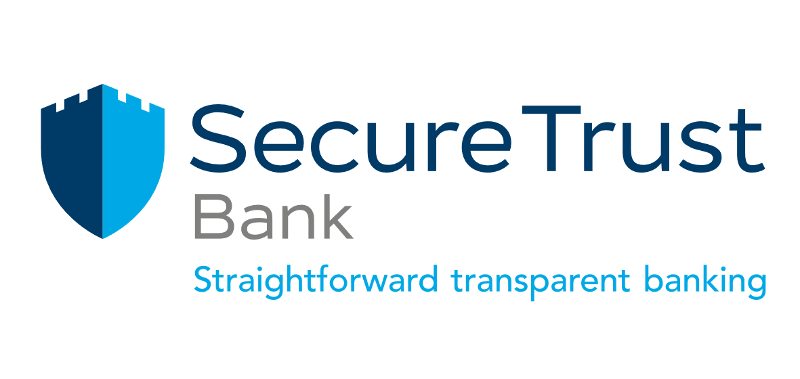
Quality Assurance Apprentice (Real Estate Finance)

Job Level: TBC
Career Path:
Reporting To: Quality & Standards Manager Real Estate Finance (REF)
Location: London/Hybrid

Secure Trust Bank is an established, well-funded and capitalised UK retail bank with a 70-year trading track record. We operate principally from our head office in Solihull, West Midlands, and had 950 employees (full-time equivalent) as at 31 December 2020. The Group's diversified lending portfolio currently focuses on three sectors (i) Business Finance through its Asset Finance, Commercial Finance and Real Estate Finance Divisions (ii) Consumer Finance through its Motor Finance and Retail Finance Divisions.
Our customers are at the heart of everything we do, but we cannot achieve our customer focused strategy without the right people in our team. At Secure Trust Bank, we know that people are our biggest investment, which is why a career with us is not just a job. It is the chance to be part of something bigger, to add real value to the Bank and help us constantly improve, in order to achieve our ambition of becoming the best bank in Britain. We believe in giving our staff autonomy, with initiative and exceptional performance recognised through a variety of individual and team awards and incentives. All our employees have a tangible impact on the Group’s core values, and we are looking for candidates who are enthusiastic, proactive and enjoy working in a fast-paced environment. So, join us as we strive to Grow, Sustain and Love the way we work.
Job Description | Job Purpose  This role will execute the REF Business plan for the completion of end-to-end Quality Assurance and monitoring. Confirming that processes and procedures are operating efficiently and safely to achieve outstanding customer experience and risk mitigation for the business. Support in the delivery of operational process and procedural change as identified from QA findings  Key Responsibilities  - Execution of quality assurance activity including:  - Monitoring of the end-to-end REF processes in line with the REF quality assurance (QA) framework highlighting any business or customers risks.  - Conduct quality assurance checks against operational processes.  - Review of Operating Platform records to ensure adherence to REF data quality standards including minimum levels of data entry (nCino & Aurius) and governance (i.e. Document Manager, postings, adjustments, repayments and production of redemption statements)  - Review of iDrive Customer files to ensure adherence with STB Records Management Policy  - Review of Credit risk activities to ensure adherence to STB policies and procedures  - Review of Companies House and Equifax activities to ensure adherence to governance  - Production of periodic QA test results management information (MI), providing constructive feedback to management and liaison with appropriate stakeholders in respect of remedial action plans.  - Investigation of findings and making recommendations on appropriate remedial work, process improvements or training requirements.  - Create and maintain accurate and timely records of any Operational Incidents with REF Quality Assurance & Governance Team for escalation via Operational Risk Management System  - Maintain up to date knowledge and understanding of the core products, processes and regulatory policies and procedures in order to provide specialist assistance and share best practice  - Support ad-hoc projects, being a subject matter expert ensuring that all internal processes are followed, and actions are completed within the agreed timescales.  - Support REF systems releases, user acceptance and regression testing in collaboration with Quality & Standards Manager, Systems Administrator and third parties to ensure service continuity and data integrity  - Assist in the creation and maintenance of REF process maps and procedures in collaboration with Quality & Standards manager  Key Interfaces  - REF Relationship Team  - REF Quality Assurance and Governance Team  - REF Credit Risk Team  - STBG Finance  - STBG Compliance  - STBG Operational Risk
Specification | Knowledge, experience, skills, other attributes  - Ability to engage and influence multiple stakeholders at various levels across STB  - Strong verbal and written communication, analytical skills, problem solving and judgement  - Attention to detail and accuracy  - Ability to work in a fast-paced environment, prioritise, plan and execute to agreed timelines under limited supervision  - Good IT skills  Qualifications  - Professional banking qualification (advantageous)  - Quality management qualification (advantageous)  Behavioral competencies  - Risk Aware – We keep our customers and ourselves safe and secure  - Customer focused – Our customers are at the heart of everything we do  - Ownership – Being accountable and taking responsibility for our actions  - Performance Driven – To become the best bank in Britain we need to be accountable for what we do  - Team Oriented – We achieve more when we work well together  - Future Orientated - Embracing change and implementing good ideas gives us the competitive edge

